***Day 2 Lab Assignments***

1. *Use JS constructor function to create the following custom types:*

*a. Create custom type “Person” that has Name and age properties.*

*b. Use prototype property to add PrintPerson() method to the class.*

*c. Create student object that inherits from Person, and its constructor have two member variables (Faculty and Total_mark), and put default value for Total_mark to be 0 (Using Function Constructor).*

*d. Use prototype property to add PrintStudent() method to the class in students.*

1. *Create factory function that returns an object of Course [Use factory function pattern].*
2. *What’s the output of the following piece of code? Explain the code and the output.*

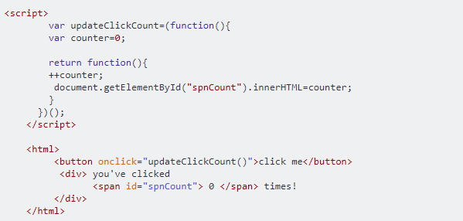

* + 1. *Explain the use self-invoking functions in the previous piece of code.*
    2. *Explain the use of closures in the previous piece of code.*

*3. Create an object user with the following properties:*

* *firstName: A string representing the user's first name.*
* *lastName: A string representing the user's last name.*
* *greet: A method that logs "Hello, [firstName] [lastName]!"*
* *Call this method in the context of another object admin using*

# *Call, apply , bind, and* [*what is the difference between*](https://stackoverflow.com/questions/63773161/what-is-the-difference-between-data-descriptors-and-accessor-descriptors) *them*

**<Script>document.write(“Thank YOU”) </Script>**